## **Concept Note**

## **Establishing the Value of Water in Tanzania**

#### Evaluating the contribution of water resources in the country’s economy

#### **Background**

Water resources provide substantial benefits to sustainable development and socio-economic well-being. Indeed, water plays a key role in most human activities and is considered a fundamental resource in many sectors including in agriculture, transport, energy, manufacturing, tourism among others. Yet, water resources are often mismanaged as seen with challenges related to pollution, over abstraction, misallocation, floods, droughts, etc. Such problems inflict great economic losses; in Africa, for example, it is estimated that the lack of proper water and sanitation create the equivalent of 5% losses in GDP and floods and droughts can decrease the national economy by 5 to 25%[1]. Often, decision makers are however poorly informed on the actual costs and benefits related to water and therefore underestimate the need to invest in strengthening water governance systems. Evaluating the economic contribution of water and recognising its true value thus constitute a great basis for improving water management and policy decisions.

Plagued with significant water challenges, Tanzania is a country that would certainly benefit from better understanding of all the costs and benefits which water brings to its economy. Some of the key water concerns in the country relate to the high demand and poor water efficiency in the mining, industry, and agricultural sectors[2]. Mineral resources extraction, which accounts for 4.8% of GDP and about 50% of the country’s foreign exchange earnings, causes significant water stress and pollution[3]. Groundwater abstraction in urban areas, especially Dar es Salaam where about 80% of the industries are located, is rapidly increasing due to the need for reliable water supplies to sustain industrial production. Similar patterns of surges for water demand are observed in Arusha, Mwanza and Mbeya Cities (Water Sector Status Report, 2020). Many private wells have been constructed by industries and individuals to provide a reliable supply. Rufiji basin leads with the highest water abstraction quantities of 34%, followed by Ruvuma Basin (27%), which is linked with intensive irrigation activities. Besides problems of over abstraction, the country also faces a major issue of water pollution and wetlands encroachment caused by the expansion of agricultural, industrial, and tourism activities[4]. All of these water-related challenges affect Tanzania’s environmental security, its social wellbeing and its economy.

Tanzanian policy makers and financial decision makers would be much better equipped to make more informed decisions on how to solve these issues if they were given a more complete picture of the value that water brings to each of those sectors and to the national economy. As a follow-up activity to the IWRM Action Plans produced under Stage 2 of the SDG 6 IWRM Support Programme, the proposed activity will focus on paving the way for greater commitment from multiple stakeholders towards economic investment in the implementation of the activities outlined under Stage 2, thus transitioning towards Stage 3 of the Support Programme, focused on implementation (see Figure 1).

**Figure 1.** Stages of the SDG 6 IWRM Support Programme.



#### **Objectives of the study**

The objective of this study is to **establish the economic value of water in Tanzania as a means to support policy makers to take more informed water-related decisions**. To build a more comprehensive understanding of the total economic value of water in the country, it is proposed that a priority focus should be on selecting economic activities/sectors with major water performance issues where there is an incomplete understanding of costs and benefits associated to the resource. This will reveal the extent to which the benefits related to water have been traditionally undervalued, thus establishing a strong economic rationale for further investing in good water governance. At the same time, another interlinked objective is to identify whether improvements could be made to the cost and benefit sharing structures, especially in terms of who is bearing the negative externalities and the extent to which these can be decreased. This strong conceptual framework will then be used to explore different policy options in various development scenarios to see what would happen to the total economic value of water in that context. Specific activity objectives include to:

* Identify key economic activities/sectors linked to major water performance issues where the value of the resource is poorly understood, based on the previous Baseline Action Rationale study (BARD) conducted by Global Water Partnership in 2021-22.
* Select the appropriate economic valuation approaches and methods to reveal all the costs and benefits of water in these key selected economic activities/sectors (e.g., through revealed, cost-based, and stated preferences approaches, see Figure 2).
* Engage with key stakeholders in the water sector as well as water-related ministries in the design and methodology of the study e.g, the Ministry of Energy, Ministry of Agriculture, Ministry of Livestock and Fisheries, Ministry for Industry and Trade, Ministry of Health, Ministry of Natural Resources and Tourism, Vice President’s Office (Environment), Ministry of Finance and Planning among others. This will take the form of a national workshop.
* Present the methodological framework to the Management of Ministry of Water as well as Donor Partner Group on Water with the objective to reach out to key stakeholders for further input and consultations.
* Develop a macroeconomic understanding of the total economic value of water in Tanzania as a means of reinforcing the investment rationale for improving water management.
* Study cost and benefit sharing arrangements between various stakeholders (water users, industries, etc) and who bears the brunt of externalities.
* Discuss and identify how certain policy decisions would impact the total economic value of water while maximising the social and environmental benefits, looking at the current baseline and possible future development scenarios, including proposed actionable recommendations.
* Present the outcomes of the study and proposed recommendations to an inter-ministerial team (from water related ministries) for further input.
* Present the final outcome to the management of the Ministry of Water for adoption.
* Launch the “Economic Value of Water in Tanzania” report during the 2022 annual National Multi-Sectoral Forum on water resources management where all water-related sector ministries, key stakeholders including development partners will be present (most likely the annual convening will be in November/December).
* Agree on possible next steps, including potentially the endorsement of the report’s findings, guiding future investment decisions and budgetary allocations.

**Figure 2.** Overview of Valuing Water Methods (IUCN, 2004[5]; WRG 2030[6])

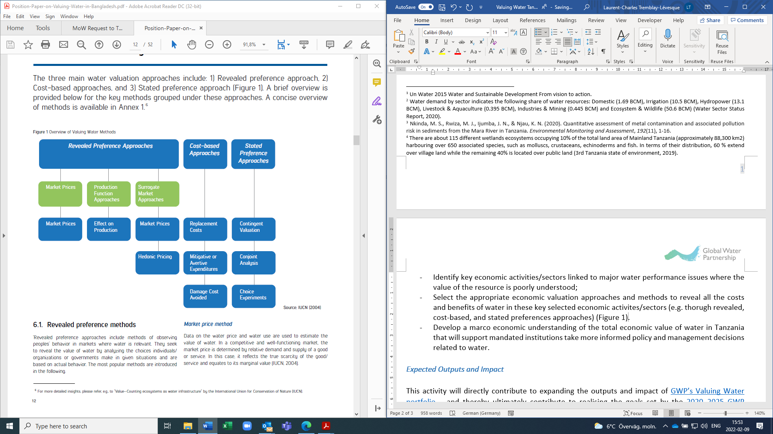

#### **Expected Outputs and Impact**

This activity will directly contribute to expanding the outputs and impact of the global valuing water initiative and in particular [GWP’s Valuing Water portfolio](https://www.gwp.org/en/we-act/campaigns/high-level-panel-on-water-valuing-water-initiative/) and the [SDG 6 IWRM Support Programme](https://www.gwp.org/en/sdg6support/) Specific activities under this study is as indicated in Table 1. It may also be considered a contribution to the Valuing Water Initiative, led by the Dutch government.

Furthermore, while the intention of this report is to establish the true value of water for Tanzania as a whole, it is however recommended that the experiences in the Wami-Ruvu basin could be used as case studies for the broader analysis. In this light, the expectation is that this activity should facilitate the implementation of the four Action Plans for Tanzania developed under Stage 2 of the SDG 6 IWRM Support Programme, which were developed with a main focus on the Wami-Ruvu basin. Ultimately, this activity will contribute to facilitating improvement in Tanzania’s score for the degree of implementation of Integrated Water Resources Management (IWRM), as measured through SDG indicator 6.5.1.

#### **Timeline**

The development of the proposed activity is expected to take place between May and November 2022, with the aim of presenting the results at the annual National Multi-sectoral Forum on water resources in November (Table 1).

**Table 1**. Activity Timeline

|  |  |  |  |  |  |  |  |
| --- | --- | --- | --- | --- | --- | --- | --- |
| Activity | May | June | July | Aug | Sept | Oct | Nov |
| Desk review of potential key economic activities/sectors and development of economic valuation techniques (methodology) |  |  |  |  |  |  |  |
| National consultation workshop for key stakeholders and water sector related ministries including MoW management and Donor Partners Group representatives (to discuss and validate the methodological framework) |  |  |  |  |  |  |  |
| Undertaking of the study (applying the methodological framework) |  |  |  |  |  |  |  |
| Present the outcome of the study to inter-ministerial team (water related ministries) including to the Management of Ministry of Water |  |  |  |  |  |  |  |
| Official launch of the report “Economic Value of Water for Tanzania” during the 2022 National Multi-sectoral forum |  |  |  |  |  |  |  |

#### **Budget**

Given the intensive and extensive consultation nature of the exercise, the provisional budgetary requirement for the whole exercise is estimated to be EUR 51,500. GWP will provide an indicative support of EUR 20,000 from the SDGs and the Multi-Stakeholder Processes budgets. This indicative budget will cover time input of the consultant and not facilitation to convene or participate in the stakeholder processes. It is envisaged that the other cost of EUR 31,500 will be covered by Ministry of Water and or other development partners to cover all convenings and stakeholder engagement processes. The budget allocation is as follows:

|  |  |  |
| --- | --- | --- |
| **#** | **Activity** | **Amount (EUR)** |
| 1 | Consultancy services (time input) | 20,000 |
| 2 | National Stakeholder Consultation Seminar/conference to share methodology, process of the study and get contribution from all sectors. | 15,000 |
| 3 | Presenting outcomes of the study and proposed recommendations to an inter-ministerial team (from water related ministries) for further input and validation. | 10,000 |
| 4 | Presenting the final outcome of the study to Management of MoW | 2000 |
| 5 | Launch of the study results during National Multi-Sectoral Forum | 4,500 |
|  | **TOTAL** | 51,500 |

1. UN Water (2015). Water and Sustainable Development From Vision to Action.
2. Water demand by sector indicates the following share of water resources: Domestic (1.69 BCM), Irrigation (10.5 BCM), Hydropower (13.1 BCM), Livestock & Aquaculture (0.395 BCM), Industries & Mining (0.445 BCM) and Ecosystem & Wildlife (50.6 BCM) (Water Sector Status Report, 2020).
3. Nkinda, M. S., Rwiza, M. J., Ijumba, J. N., & Njau, K. N. (2020). Quantitative assessment of metal contamination and associated pollution risk in sediments from the Mara River in Tanzania. *Environmental Monitoring and Assessment*, *192*(11), 1-16.
4. There are about 115 different wetlands ecosystems occupying 10% of the total land area of Mainland Tanzania (approximately 88,300 km2) harbouring over 650 associated species, such as molluscs, crustaceans, echinoderms and fish. In terms of their distribution, 60 % extend over village land while the remaining 40% is located over public land (3rd Tanzania state of environment, 2019).
5. IUCN (2004). Emerton, L., Bos, E. Value: Counting Ecosystems Water Infrastructure. IUCN, Gland, Switzerland and Cambridge, UK.
6. WRG 2030 (2020). Position Paper on Valuing Water in Bangladesh [Position-Paper-on-Valuing-Water-in-Bangladesh.pdf (2030wrg.org)](https://www.2030wrg.org/wp-content/uploads/2020/11/Position-Paper-on-Valuing-Water-in-Bangladesh.pdf)